NATIONAL UNIVERSITY OF COMPUTER AND EMERGING SCIENCES

**MEMBERS:**

**MOHAMMAD YASIR JAMAL: 20K-0158**

**ABDUL BASIT: 20K-0333**

**MUHAMMAD WARZAN: 20K-1649**

**ANAS HASSAN: 20K-1726**

**ESSAY:**

**AN EFFECTIVE SPEAKER**

**(BARACK OBAMA)**

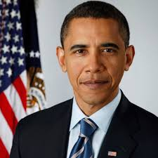

Our history is full of such speakers who will always be lingered in the hearts of listeners for their oral skills. Barack Obama is one of them. After listening to his last address, I am once again reminded of how amazing his delivery abilities are. Here are some reasonswhy Obama will be remembered as one of the greatest speakersof all time.  
Obama speeches have one clear cause and Obama accomplishes that with ease. He is mindful of exactly what to say to make people agree with him by creating contrasts between a problem and a solution. He knows his audience and analyses what he should say that is appropriate for them. Countless time in his speeches, Barack Obama used “we” rather than “I” and made the people of a particular city or the whole country believe they have done something which they can be proud of.

Obama’s delivery is his greatest strength. From the moment he enters the stage, it is clear that he is very confident. He looks at the audience and maintains good eye contact. His gestures feel natural and appropriate. His he pauses between topics, and his facial expressions help him to communicate with the audience. Everything from his posture, to his facial expressions, is done for a reason. He delivers his talk to the audience effectively without boring them. One act he did often was to reach out to his heart, a sign of sympathy when they talk about a matter that is close to their heart.

Barack Obama spoke simply, keeping in mind his audience. His body language and gestures helped him get his point across to the audience. These qualities made him one of the best speakers of all time.